BB eBooks- Bangkok, Thailand

Paul Salvette- Managing Director/Co-Founder

01/10/2014

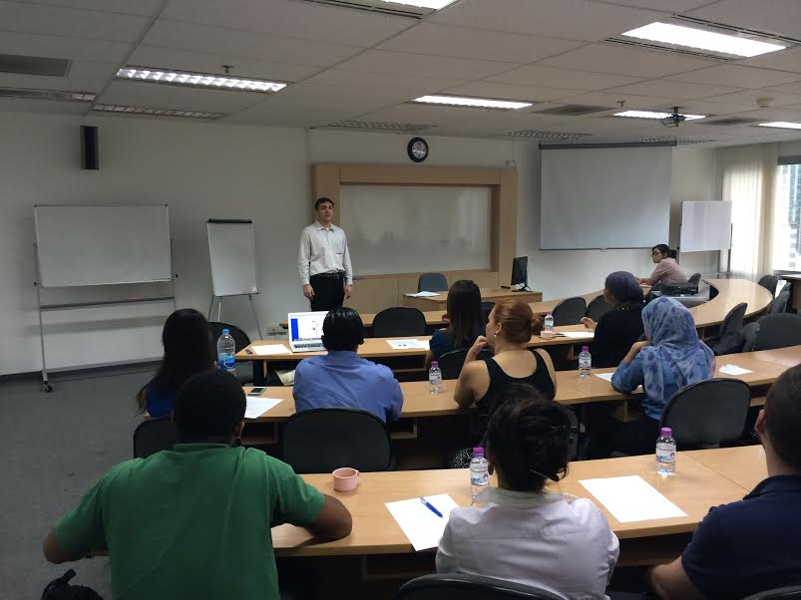

An MBA student in today’s economy is asked, “What are your career goals/ambitions?” It appears that the majority answer is, “To one day start and operate my own company.” With the development of technology, theavailability of resources to secure start-up funding in a variety of ways, this realization seems to be taking place all over the world. Especially in hotbeds such as Silicone Valley and Singapore where there is depth in the talent pool.
It takes a certain personality and drive to be successful in business as many fail. The MBA class in Bangkok was able to hear a success story in the form of Paul Salvette who co-founded and currently runs BB eBooks in Bangkok, Thailand. After graduating UCLA in 2002 with a B.S. in Chemical Engineering, Paul joined the Navy, based in Hawaii from 2004-07 and in Iraq from 2007-08. At the time, he wrote a book entitled, “America Goes On” and today has written many titles, focused in the romance genre.
An avid blogger as well, Paul realized a need in the marketplace. Without any prior technical knowledge, the process to design and develop an eBook out of a manuscript is very difficult. As many romance authors are self-published, Paul was able to find his niche market and started BB eBooks with his wife in 2013. As the internet allows for firm such as BB eBooks to operate out of any location, Paul developed his business in Bangkok, Thailand. The majority of all his clients are romance authors from the UK, the US and Australia. Paul explained about looking at the business structure, plan and the ability to fund your start-up. Is this a business you can raise capital from personal, friends, family or will you need Angel and/or Venture capital? Paul was able to tap his personal savings from the military and had initial start-up costs of $60,000 for BB eBooks. It goes to show through Paul’s firm, that if you do find a niche market and have the expertise/background, desire to learn and willingness to be a workaholic it doesn’t always require millions to start a business. Jeff Simcox will present to the MBA class on October 13th, about writing a solid business plan and securing funding for a start-up.
If you listen to many different entrepreneurs speak, at the ground level, they are very similar and Paul helped to reiterate the following in regards to a successful start-up. Variables will always change depending on the specific business and/or situation in the current market, per Paul a few things to always consider:

- Is your business/service going to provide a need or a solution
- Are you going to be a B2B or B2C firm
- Focus on marketing (word of mouth/content marketing)
- Always deliver consistency and reliability to your customer
- Plan to work 90/100 hours each week
- Ask are you a workaholic, dedicated, passionate about this business?
- Filter out advice (Many people will offer, but not always correct)
- Read a lot of books from successful people in your marketplace

These are just a few of the things to consider, but ones that should be included when looking to write a business plan and/or getting into a start-up firm. Paul also spoke a lot about market segmentation, how are you going to do this to be successful? Look to email, media, word of mouth marketing campaigns. They can create a lot of buzz around your business and the only cost is your time. Paul also emphasized the fact of hiring a reputable, competent law firm that understands local’s laws/business to help with all technicalities, licenses, business insurance, etc. that will be needed. Paul talked about how you could be setting yourself up for failure right away if you do not spend the money to hire a good law firm right from the start.
In the end, per Paul’s talk and presentation, always try to find a solution to an issue in the marketplace. If this issues effects many different individuals, it can instantly provide demand for your service and/or product. As with BB eBooks, all the tech companies now have an e-reader and paper books are dying, this provided a large opportunity in the market. Position your product right in the market and listen to your customer, they will always provide valuable insight to if you are succeeding. In the final thought and statement from Paul, “Resolve customer issues instantly,” if not, you will be set-up to fail very quickly.

If you are interested in the world of e-books, writing, publishing, blogging, etc. Please find Paul’s contact information below.

Mr. Paul Salvette
Paul@beebee.aisa
+66 (0)2-7423-226
